***Type: xxx***

**Forecasting Dhaka Stock Market Prices Analysis and Prediction Using Machine learning**

**Abir Hossain Rohan** **1, Shamim Miah1, Md Jayed Hosen 1, Syeda Rabita Alam1 and Dr Mohammad Monir Uddin 1\***

1Department of Electrical and Computer Engineering, North South University, Bashundhara, Dhaka – 1229, Bangladesh

*Corresponding Author: . Email: @northsouth.edu

Received: XX Month 202X; Accepted: XX Month 202X

**Abstract:** Stock market forecasts focus on predicting the long-term prices of a company's stock or other financial instruments listed on a monetary exchange. The stock exchange, a volatile financial sector, attracts a significant number of investors,purchasers, and sellers**.** Predicting stock market prices is a difficult endeavor and often necessitates a lot of human-computer interaction. Stock exchange processes are risky and are subject to a variety of factors. People who invest in the stock exchange do so because they believe certain predictions will come to pass. Stock market forecasting is both appealing and difficult. Prudence is essential while purchasing and selling stocks from different companies and enterprises. For this reason, stock market forecasting is an important economic and financial endeavor. This research paper examines forecasting strategies based on deep learning predictive algorithms and proposes an independent model-based technique for stock price prediction. The predictive model is based on the long-short-term memory (LSTM), autoregressive integrated moving average (ARIMA), Prophet, and GRU models that specialize in classifying and predicting time series data. All four of these models perform rigorous theoretical analysis and estimate RMSE (root mean square error), MSE (mean score error), and MAE (mean average error) to :improve prediction accuracy. This study also analyzes historical price directions versus stock charts and predicts future price fluctuations for the security. The research analysis uses open, close, high, and low prices with volume information in order to create a stock chart in order to determine the direction of the price protection and support the previous information. The findings are used to evaluate data from the Dhaka Stock Exchange.

**Keywords:** Stock market; Prediction; LSTM; ARIMA; Prophet; GRU; RMSE; MSE; MAE; Dhaka Stock Exchange

**1 Introduction**

The Dutch East India Corporation was Amsterdam's first publicly traded company, and it pioneered modern stock trading. To raise funds, the corporation chose to sell stock and provide dividends to shareholders. The Amsterdam stock market was established in 1611. For many years, the only trading activity on the market was the trading of Dutch East India Company shares [1]. A stock exchange, often known as a stock market, is a real or virtual location where investors may purchase and sell stock in publicly listed firms. Each share's price is determined by supply and demand. The greater the demand for shares, the higher the price [2]. When there is less demand, the price of a share falls.

We now live and breathe data. Forecasting stock exchange data is a critical financial issue that incorporates the premise that basic information made public in the past has some predictive links to future stock returns [3]. Stock market forecasting includes recognizing market trends, preparing investment strategies, determining the optimum time to buy stocks, and deciding which stocks to buy [4]. A stock exchange or equity business community is a non-linear, non-parametric framework that is challenging to represent with any degree of precision. It is a group of speculative investors who really need to buy, sell, or hold a share at a specific time [5]. The country's stock market provides good prospects for shareholders to reap long-term advantages or trade on the stock by purchasing a stock and becoming a shareholder [6]. The share market is fast-paced and turbulent. The start-up of a firm, as well as other unforeseen national, global, and societal events, has an immediate negative or positive impact on stock values [7]. As a consequence, it is impossible to anticipate stock prices and their movements with any degree of reliability; instead, stock traders simply forecast key future changes. Generally, investors decide whether they should purchase or sell a stock depending on the company's past and present performance. The factors for analyzing the company's success often comprise numerical data and important news [8].

The start-up of a firm, as well as other unforeseen national, global, and societal events, have an immediate negative or positive impact on stock values. As a result, it is impossible to anticipate stock prices and their movements with any degree of certainty; instead, stock traders simply forecast key future changes [9]. Generally, investors determine whether to purchase or sell a stock based on the company's past and present performance [10]. The factors for analyzing the company's success often comprise numerical data and important news [11]. With its high demanding risks and high return returns, the stock market is garnering an increasing number of people's attention these days. A stock exchange market shows savings and investments that are beneficial to the national economy's efficacy [12]. The publicly accessible information of current and past stock market indexes has some predictive links with future stock returns. ARIMA is a statistical model that has been shown to be effective for time series forecasting, particularly short-term forecasting[ 13]. In light of the current economic situation, we can confidently identify the stock market as one of the most dynamic systems in existence in today's globe. The notion of projecting stock market return has grown in popularity, maybe due to the fact that if the future market value of stocks can be properly forecasted, investors can be better directed. The success of investing and trading in the stock market is heavily reliant on the system's predictability, which in turn prepares investors for future uncertainties and dangers linked with the market [14]. Due to the general complexities of the stock market, stock trend forecasting is considered the most challenging task in money-related analysis. Many stock market investors are looking for a strategy that may assure a quick profit by anticipating stock movements while minimizing the danger of investing [15]. This encourages domain researchers to explore deeper and build new forecasting models. Time series data analysis approaches employ verified facts as the foundation for predicting future outcomes. Time series data is defined as numerical data gathered in a certain sequence of regular items over a period of time [16]. Time series data might comprise numbers gathered just at the end of each week, month, quarter, or year, for example. The aim is to find out if there is a relationship between the data acquired thus far and how the data changes. Stock exchanges promote the exchange of securities between sellers and buyers in order to decrease investment risk. A stock exchange is an organization or a location where stock dealers and investors may trade equities.

A share market represents investments and savings that benefit national economic effectiveness. The publicly available data of current and historical stock market indexes has some predictive links with future stock returns. Based on earlier connections, investors determine the best moment to sell or purchase a company in the share market. Every investor, whether a long-term investor or a day trader, is fascinated by projecting future stock values. This is a significant problem in terms of designing and developing a proper and effective forecasting model that supports investors in making suitable selections.

 There are some existing prediction systems. The author has done good research and proposed the prediction system by applying different classification and prediction algorithms.

In this paper [17], using DL for financial market forecasting has been considered, utilizing long-term and short-term memory networks.  The authors of this research divided the experiment into three sections, the first of which was a modest introduction to LSTM. In the second half, they attempted to decipher the LSTM network's black box and demonstrate why it was a viable design for forecasting methodologies. Finally, they devised a rule-based trading technique that determined if the stock would be profitable or not.

 The authors of this work [18], explored the prediction of stock prices using LSTM, ARIMA, and UCM. The authors employ LSTM (Long Short-Term Memory), ARIMA (Autoregressive Integrated Moving Average), and UCM (Unobserved Component Model) in this study. These models are used to forecast future points in a series using time series data. The authors compared and contrasted the processes and outcomes of several models.

The authors of the study experimented with several machine learning algorithms and presented their findings in three sections [19]. The next period's direction comes first, followed by the next period's price change, and finally the next period's actual price. The authors of this article concluded that deep learning approaches, which we also attempted in our work, may improve their results.

In this paper [20], the authors described a recurrent neural network approach to predicting daily stock prices for the Sri Lankan stock market. The authors of this research used recurrent neural networks to conduct an experiment on the Sri Lankan stock market and examined the performance of several recurrent neural networks on the dataset.

In this research paper [21], Stock Prediction Using a Deep Learning Model Based on Technical Indicators uses STIs (Stock Technical Indicators) to develop an Evolutionary Deep Learning Model (EDLM) to determine stock trend prices.. This study used LSTM, which is utilized to analyze the dataset of the three most popular banking companies gathered from the live stock market based on the National Stock Exchange (NSE) – India.

Hiransha et al. [22] showed the performance of four deep learning architectures: RNN, CNN, MLP, and LSTM in forecasting day-by-day stock prices from the NSE. When CNN was trained on NSE data, it performed far better, as well as being able to estimate NYSE. The linear and nonlinear models were compared by the authors. The ARIMA model, which is likewise a linear model, is used as a comparison.

In this research [23], the authors employ a neural network approach to forecast the stock market. Data from live stock markets was collected for genuine then off-monitoring, visualization, and analysis of findings for digital internet stock analysis. Depending on the outcomes of a word vector investigation, they clarified the "stock vector theory." It is neither a solitary index nor an accessible inventory index, but rather historical data for several inventories.

The main objective of this research is to forecast the future stock market indices using time-series ARIMA, LSTM, GRU, and Prophet models. In this paper, we present a prediction model for time-series stock market data. This system will automate the process of changing stock price indices based on technical analysis and will aid financial professionals in selecting the best time to buy and sell companies. The prediction model is built using deep learning techniques, which are then utilized to visualize the findings. However, the novelty in our research is the use of some well-known deep learning methods for the forecasting of stock market best results.

As previously stated, the primary contribution of our research is that we used a publicly available dataset to apply multiple deep learning models. The majority of researchers used a large model to predict stock market price in previous studies. We did, however, utilize four alternative models and compared the findings to previous research. The results and comparisons are discussed in depth in the next section. The following is the rest of the article: Section 2 describes experimental procedures and materials. Results and analysis were provided in Section 3, and conclusions were discussed in Section 4.

**2 Method and Materials**

This area includes a detailed description of the datasets, workflow diagrams, and the research processes and methodology.

***2.1 Dataset***

This paper refers to the Dhaka stock exchange dataset that is derived from the Kaggle website. The dataset provides five different companies' datasets, i.e., AB Bank, Square Pharmaceuticals, Renata, BSCCL, and IFIC. The IFIC data consists of 1927 rows with 14 columns, or significant parameters. These 14 significant parameters, or attributes, are preprocessed and trained to predict the stock market values. Attributes or parameters are date, last_traded_price, high, low, opening_price, closing_price, trade, value_mn, volume, month, day_of_month, day_of_year, and day_of_week.

Dataset link: <https://www.kaggle.com/datasets/muhaddidalavi/top-15-organizations-data-of-dhaka-stock-exchange?resource=download>

***2.2 Proposed system and Methodology***

To implement our research, we compiled 4 different deep learning models i.e., Arima, LSTM, Prophet, and GRU. These four are most common among the value forecasting algorithms. In this research we tried to measure performance among the deep learning techniques on data from five different companies to determine which technique suits the most for these companies. Figure 1 shows the workflow diagram of the system.

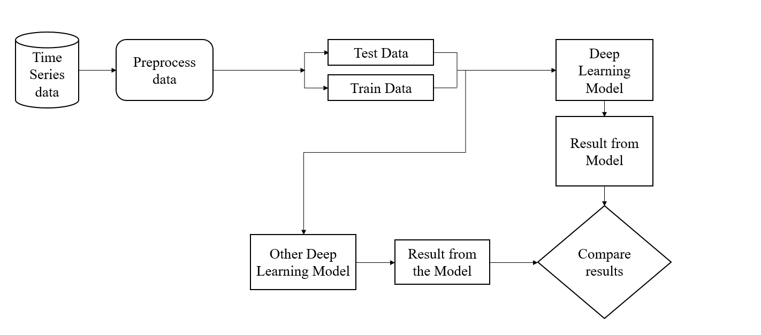

Figure 1: Workflow diagram of the experiment

**Step 1**: Necessary library and packages were imported to use necessary classes and function belongs to them. For modeling we imported *Keras* and to analysis data we imported *Pandas*, *Numpy* and similar other libraries.

**Step 2**: All the necessary data was stored in a comma separated value (CSV) file. The CSV file was read using read_csv() function. We used data from five different companies and they are: Abbank, Square pharma, Ific, Bsccl, Renata. We had to preprocess data before training into the model. We had to remove incomplete rows and some not a number field. Besides, we took those fields that will be necessary for prediction the closing price. From figure 2, we can see the sample data from dataset of IFIC bank. Different types of information is shown according to date. In figure 3, train data and test data is visualized on a ratio of 60 and 40. The green line shows the Train data and the blue line indicates the test data. We can see a long green line compared to blue line due to the split ratio. We can see the sample data of BSCCL that is imported from csv file in figure 4. Opening price, closing price, trade, difference and more information is shown which is sorted by date in descending manner. From this dataset closing price is split into train and test data which is plotted in graph shown in figure 5. Similarly, the sample data of Renata, Square Pharmaceuticals and AB Bank is shown in figure 6, figure 8 and figure 10 respectively. Again, the train and test data of this company is visualized with green and blue lines are visualized in figure 7, figure 9 and figure 11.

**Step 3**: We took the mean value of closing price using the mean() function of *numpy* library.

mean_value = df['closing_price'].mean()

mean_value =

It made the average of numbers stored in the df[‘closing_price’] array and stored it into mean_value.

Here, closing_price is the list of closing price written in the csv file.

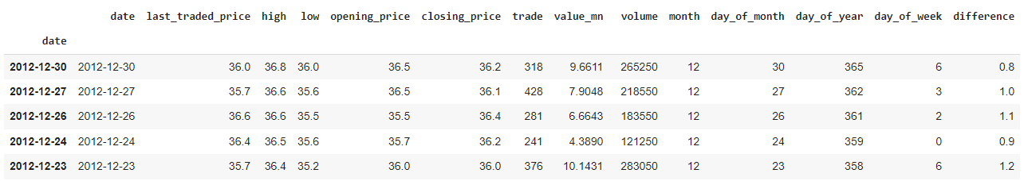

Figure 2: A sample of the raw dataset for IFIC Bank

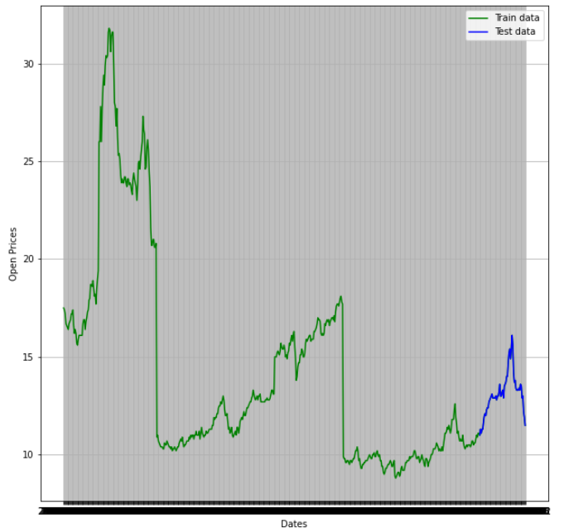

Figure 3: Visualization of Train and Test Data of IFIC Bank

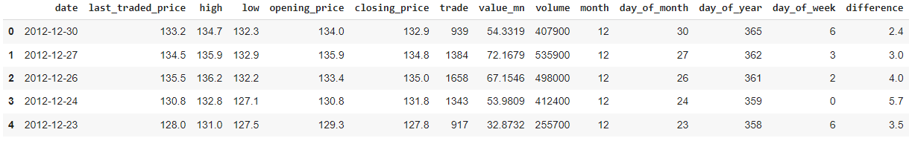

Figure 4: A sample of the raw dataset for BSCCL

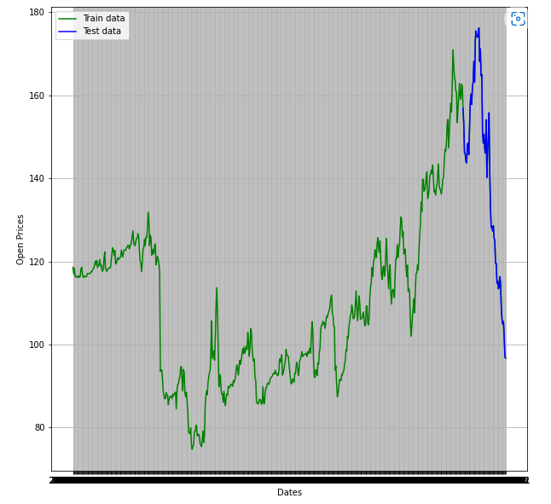

Figure 5: Visualization of Train and Test Data of BSCCL

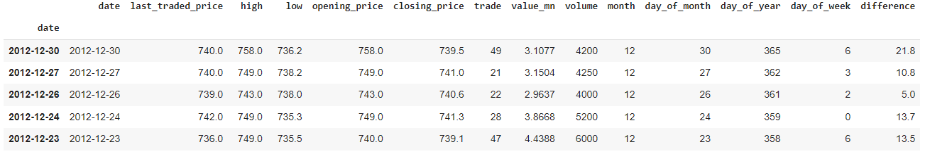

Figure 6: A sample of the raw dataset of Renata

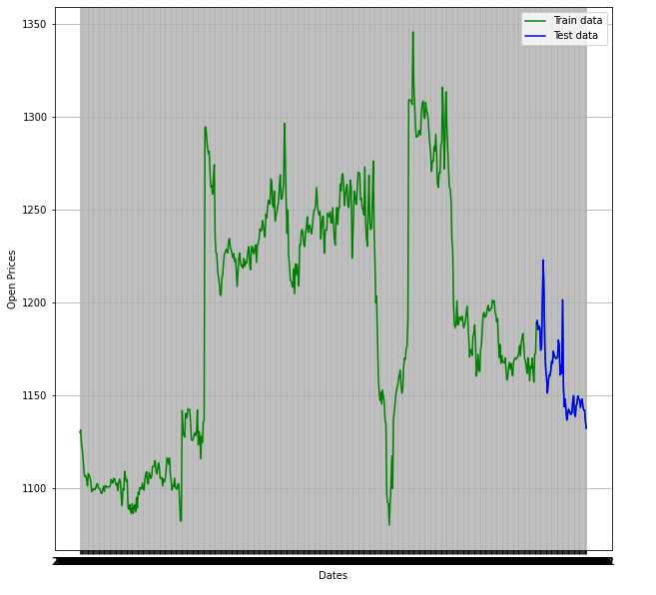

Figure 7: Visualization of Train and Test data of Renata

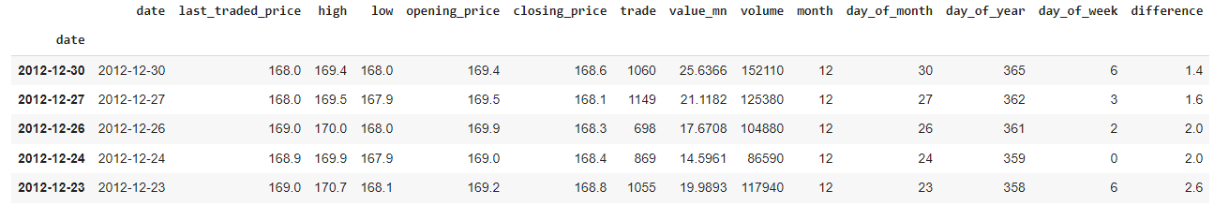

Figure 8: A sample of the raw dataset of Square Pharmaceuticals

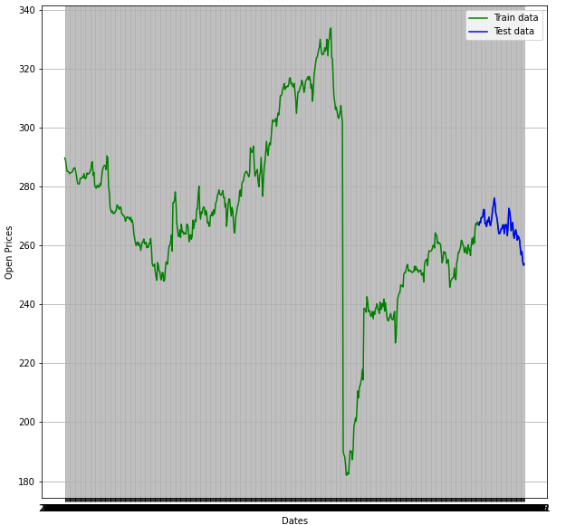

Figure 9: Visualization of Train and Test data of Square Pharmaceuticals

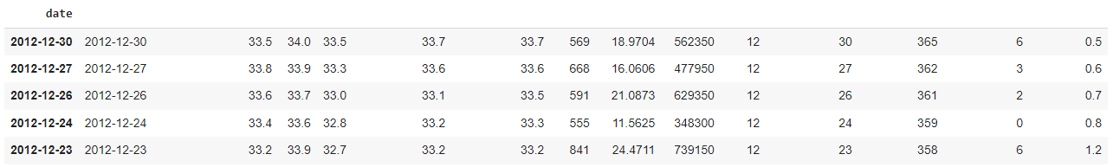

Figure 10: A sample of the raw dataset of AB Bank

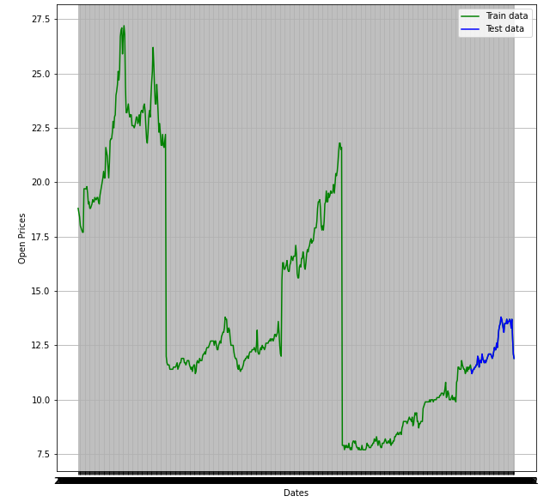

Figure 11: Visualization of Train and Test data of AB Bank

**Step 4**: We ran our models of deep learning using *Train* and *Test* data. Before that, the dataset was split into two *train* and *test* data. Ratio between *train* and *test* data is 60 and 40. No validation data is used here.

1. Use of ARIMA cell

for i in range(1, len(y)): model = ARIMA(history, order=(1,1,1)) model_fit = model.fit(disp=0) yhat = model_fit.forecast()[0]

1. User of Prophet Cell

prop.fit(ph_df_train)

future_prices = prop.make_future_dataframe(periods=73)

1. User of LSTM Cell with peephole

model = Sequential()

model.add(LSTM(units = 60, return_sequences = True, input_shape = (X_train.shape[1], 1)))

model.add(LSTM(units = 50))

1. User of GRU Cell

model.add(GRU(units = 60, return_sequences = True, input_shape = (X_train.shape[1], 1)))

model.add(Dropout(0.2))

model.add(GRU(units = 50))

model.add(Dropout(0.25))

model.add(Dense(units = 1))

model.compile(optimizer = 'adam', loss = 'mean_squared_error')

We have taken the batch size 177 and 100 epochs with 50 hidden units where activation is sent forward. In the Arima model as it is predicting further trends from time series of statistical data, the closing price was trained with ‘train_data’ where order was 1-1-0.

In the Prophet model preprocessing is required for the Prophet Model. Change point prior scale of the Prophet model was set to 0.1. Then a future date was created to process the prediction of price.

In LSTM model in the LSTM model first layer was added with 60 units and the second was with 50 units. Dense layer had one unit. It was compiled with RNN where optimizer was Adam optimizer and loss was mean square error.

In GRU model the model was trained using GRU model. Two times GRU layer was used and dropout layer was used twice as well to track over fitting. Dense layer was used once added before compiling. The model was compiled with RNN model along with Adam optimizer and mean square error loss. Finally, the model was trained.

**3 Result and Analysis**

This section examines the capabilities of the forecast stock price, model predictions, investigation, and ultimate outcomes.

**3.1 Evaluation of the Model**

***3.1.1 ARIMA***

Figure 12 shows the predicted and actual closing prices for the AB Bank data using the ARIMA model.

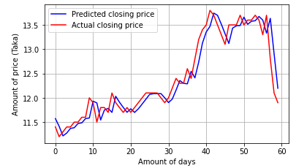

Figure 12: Predicting using ARIMA model for AB Bank

Figure 13 shows the predicted and actual closing prices for the Square Pharmaceuticals data using the ARIMA model.

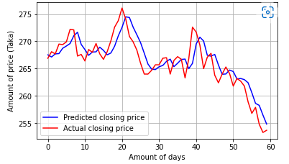

Figure 13: Predicting using ARIMA model for Square Pharmaceutical

Figure 14 shows the predicted and actual closing prices for the Renata data using the ARIMA model.

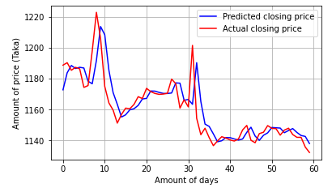

Figure 14: Predicting using ARIMA model for Renata

Figure 15 shows the predicted and actual closing prices for the BSCCL data using the ARIMA model.

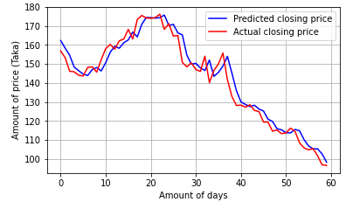

Figure 15: Predicting using ARIMA model for BSCCL

Figure 16 shows the predicted and actual closing prices for the IFIC data using the ARIMA model.

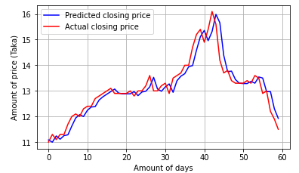

Figure 16: Predicting using ARIMA model for IFIC

In this case, Actual stock prices for AB Bank, Pharmaceuticals, Renata, BSCCL, and IFIC were obtained via the Kaggle website using the Dhaka Stock Exchange dataset, which serves as the performance measure's ground truth. The actual stock price is compared to the forecasted stock price for the testing data. The predicted and actual closing prices of the suggested five companies are also displayed in the graphs in Figs. 12, 13, 14, 15, and 16. The forecast is shown by a blue line, while the actual trend is represented by a red line. The distance between these two lines indicates how effective the ARIMA-based model is. As you can see in the above graph, the ARIMA model can accurately forecast the trend of actual stock prices. It can be seen that the stock value increases and decreases in a predictable way over the course of a day.

***3.1.2 LSTM***

Figure 17 shows the predicted and actual opening prices for the AB Bank data using the LSTM model.

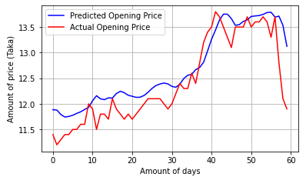

Figure 17: Predicting using LSTM model for AB Bank

Figure 18 shows the predicted and actual opening prices for the Square Pharmaceuticals data using the LSTM model.

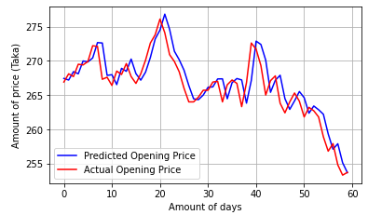

Figure 18: Predicting using LSTM model for Square Pharmaceuticals

Figure 19 shows the predicted and actual opening prices for the Renata data using the LSTM model.

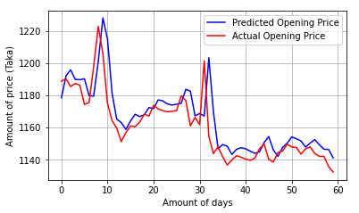

Figure 19: Predicting using LSTM model for Renata

Figure 20 shows the predicted and actual opening prices for the BSCCL data using the LSTM model.

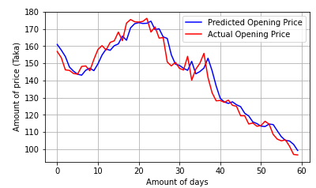

Figure 20: Predicting using LSTM model for BSCCL

Figure 21 shows the predicted and actual opening prices for the IFIC data using the LSTM model.

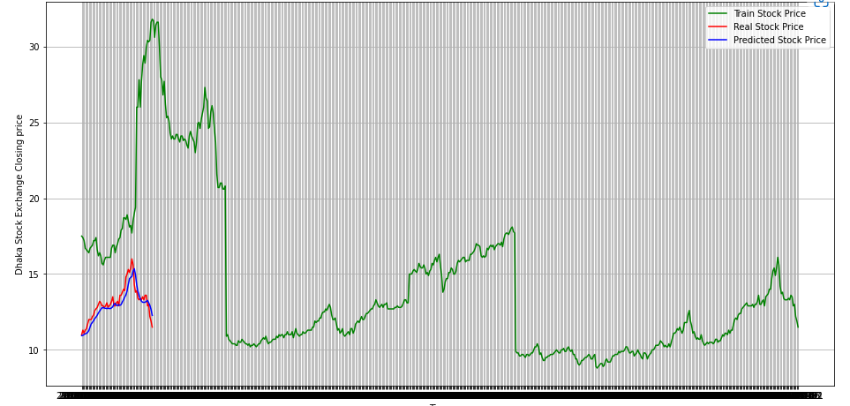

Figure 21: Predicting using LSTM model for IFIC Bank

In the above graphs in Figures 17, 18, 19, 20, and 21, the forecasted and actual opening prices of the indicated firms are also shown. The forecast is shown by a blue line, while the actual trend is represented by a red line. The distance between these two lines indicates how effective the LSTM-based model is. The LSTM model can successfully estimate the trend of real and predicted stock prices very well. Over the course of a day, the stock value rises and declines in a regular pattern. As seen in the graph, the real stock price is compared to the forecasted stock price.

***3.1.3 GRU***

Figure 22 shows the predicted close, test close and close prices for the AB Bank data using the GRU model.

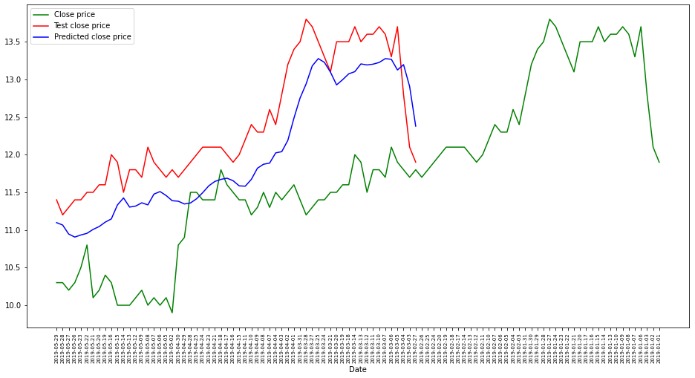

Figure 22: Predicting using GRU model for AB Bank

Figure 23 shows the predicted close, test close and close prices for the Square Pharmaceutical data using the GRU model.

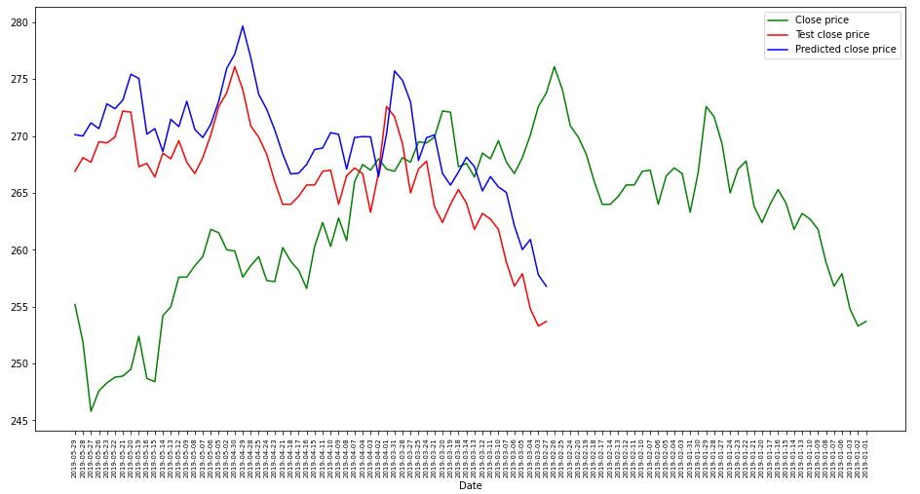

Figure 23: Predicting using GRU model for Square Pharmaceutical

Figure 24 shows the predicted close, test close and close prices for the Renata data using the GRU model.

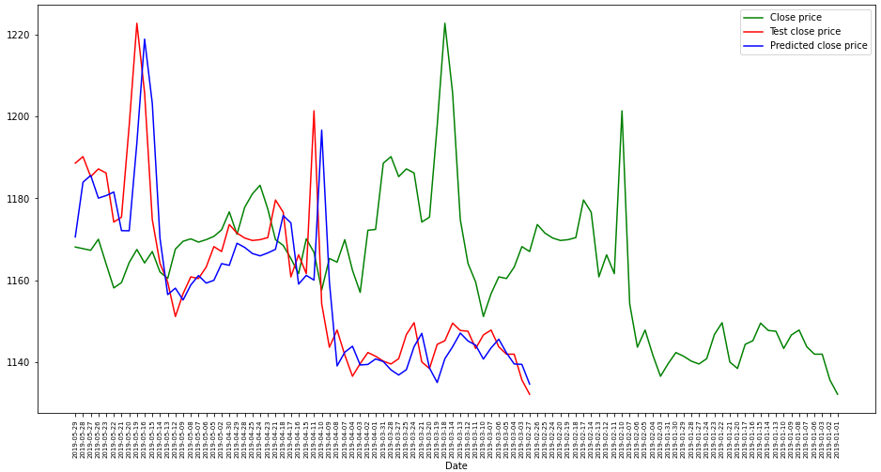

Figure 24: Predicting using GRU model for Renata

Figure 25 shows the predicted close, test close and close prices for the BSCCL data using the GRU model.

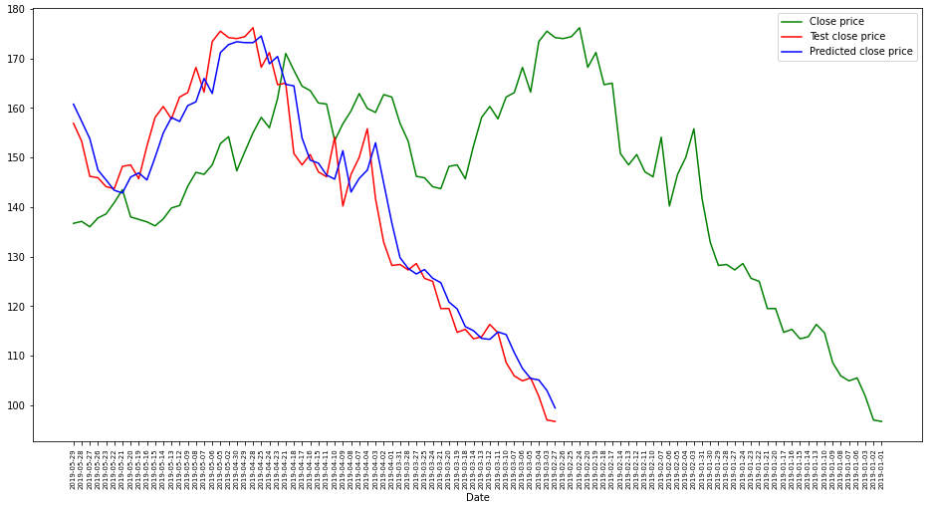

Figure 25: Predicting using GRU model for BSCCL

Figure 26 shows the predicted close, test close and close prices for the Renata data using the GRU model.

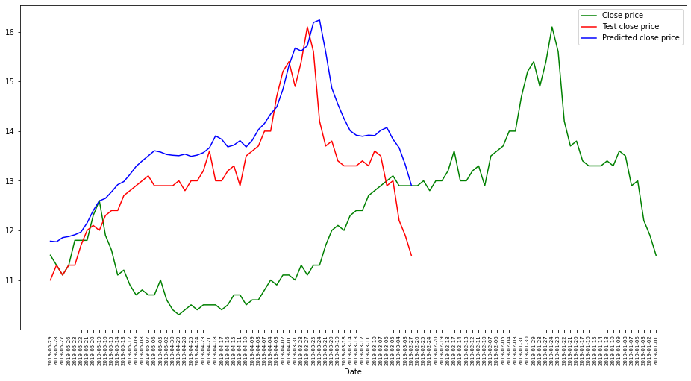

Figure 26: Predicting using GRU model for IFIC

The forecasted close, test close, and close prices of the identified companies are also displayed in the preceding graphs in Figs. 22, 23, 24, 25, and 26. The forecast is shown by a blue line, the close is shown by a green line, and the test close price is represented by a red line. The distance between these three lines indicates how effective the GRU-based model is. The GRU model can correctly estimate the trend of forecasted close, test close, and close stock values very well. The stock value rises and falls in a predictable fashion throughout the day.

***3.1.4 Prophet***

Figure 27 shows the predicted, train, and real stock prices with band ranges for the AB Bank data using the Prophet model.

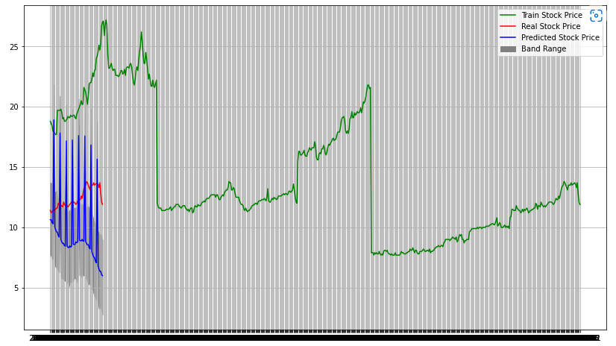

Figure 27: Predicting using Prophet model for AB Bank

Figure 28 shows the predicted, train, and real stock prices with band ranges for the Square Pharmaceuticals data using the Prophet model.

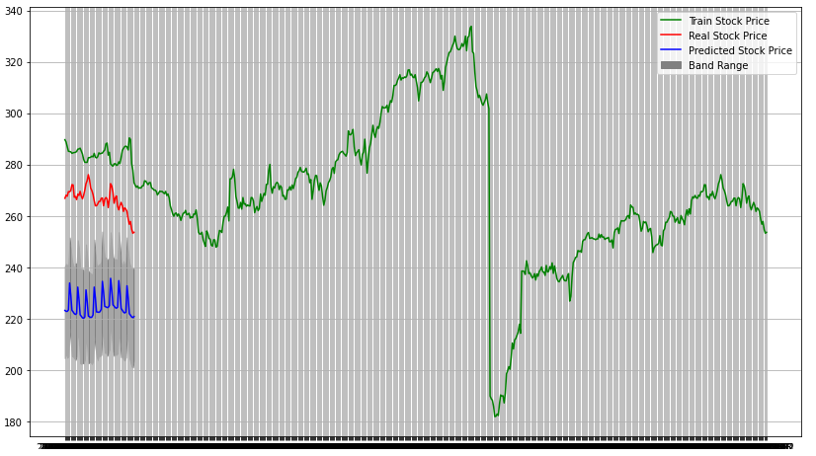

Figure 28: Predicting using Prophet model for Square Pharmaceutical

Figure 29 shows the predicted, train, and real stock prices with band ranges for the Renata data using the Prophet model.

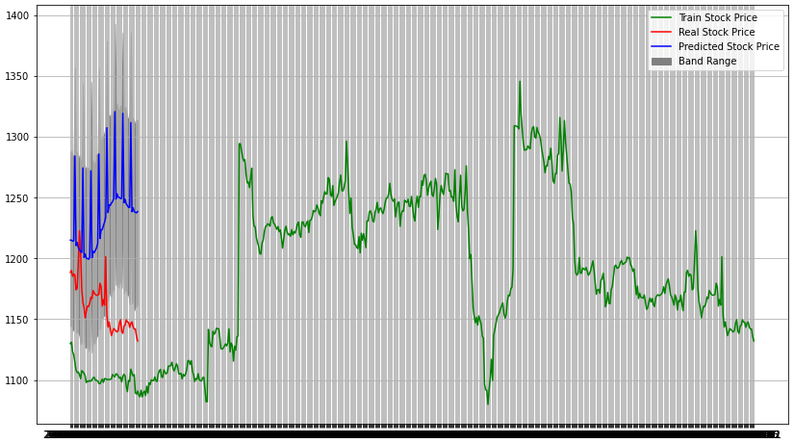

Figure 29: Predicting using Prophet model for Renata

Figure 30 shows the predicted, train, and real stock prices with band ranges for the BSCCL data using the Prophet model.

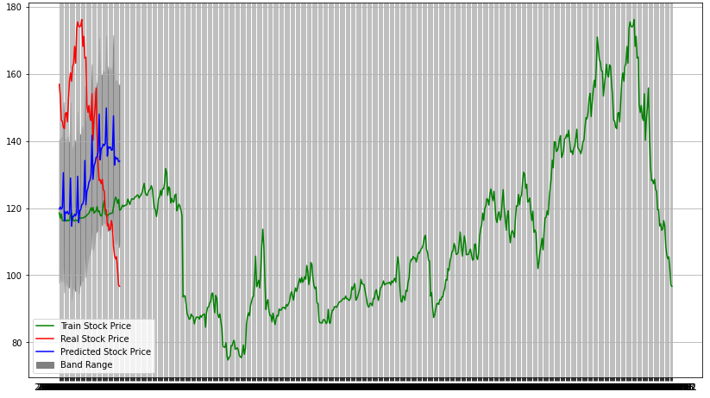

Figure 30: Predicting using Prophet model for BSCCL

Figure 31 shows the predicted, train, and real stock prices with band ranges for the IFIC data using the Prophet model.

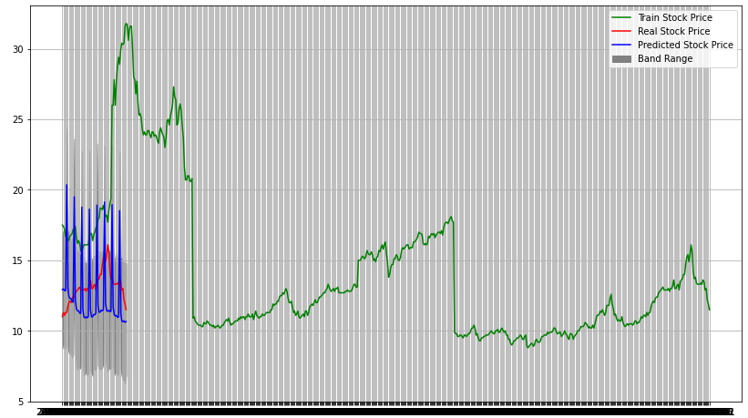

Figure 31: Predicting using Prophet model for IFIC

In Figs. 27, 28, 29, 30, and 31, the forecasted, real, train, and stock values of the identified enterprises are also represented with band rangs. The GRU model performs exceptionally well in estimating the trend of anticipated closures, forecasted, real, train, and stock values. Throughout the day, the stock value increases and falls in a regular pattern.

***3.2 Model Comparison***

In this paper, the ARIMA time series forecasting model was outperformed by all neural network architectures. The main reason ARIMA was surpassed is that LSTM, GRU, and Prophet approaches could handle massive datasets as inputs, but ARIMA could only handle a limited amount of information to generate time series data. Aside from that, neural network models might better capture market nonlinearity. The standard metrics used to compare time series data are RMSE, MSE, and MAE. The lower the scores of RMSE, MSE, and MAE, the better the model fits. Table 1 compares the RMSE deep learning models or approaches with those companies. This figure plainly shows that of the several models or approaches contained in this circumstance, the **ARIMA** model is the most efficient of the numerous models contained in the framework.

**Table 1:** RMSE error prediction

|  |  |  |  |  |  |
| --- | --- | --- | --- | --- | --- |
| Model Name | IFIC | BSCCL | Renata | Square Pharmaceuticals | AB Bank |
| ARIMA | 0.374632639716453 | 5.23212342680219 | 11.4950645421427 | 2.37150831537711 | 0.247994581831675 |
| Prophet | 2.98805512354703 | 32.4840889245364 | 86.9085187161843 | 41.792495169018 | 4.38691886209886 |
| LSTM | 0.538630419222989 | 5.22136861717391 | 11.9810466200555 | 2.14781620494157 | 0.393950896160106 |
| GRU | 0.724098405492905 | 5.1901527261214 | 10.3972766352784 | 3.85621925709714 | 0.523744254403454 |

Table 2 compares the MSE deep learning models or approaches with those companies.

**Table 2:** MSE error prediction

|  |  |  |  |  |  |
| --- | --- | --- | --- | --- | --- |
| Model Name | IFIC | BSCCL | Renata | Square Pharmaceuticals | AB Bank |
| ARIMA | 0.140349614740918 | 27.3751155532923 | 132.136508828026 | 5.62405168990277 | 0.061501312617867 |
| Prophet | 8.92847342135566 | 1055.21603325719 | 7553.09062544136 | 1746.61265245239 | 19.2450571026388 |
| LSTM | 0.290122728512333 | 27.2626902364086 | 143.545478111943 | 4.61311445020962 | 0.155197308585351 |
| GRU | 0.524318500837368 | 26.9376853204654 | 108.103361430506 | 14.8704269588068 | 0.27430804402063 |

Table 3 compares the MAE deep learning models or approaches with those companies.

**Table 3:** MAE error prediction

|  |  |  |  |  |  |
| --- | --- | --- | --- | --- | --- |
| Model Name | IFIC | BSCCL | Renata | Square Pharmaceuticals | AB Bank |
| ARIMA | 0.271143221593678 | 4.04749312957176 | 7.02169355507176 | 1.88232979958594 | 0.181546794545541 |
| Prophet | 8.92847342135566 | 29.3492888122489 | 76.0565251200951 | 41.3712729966375 | 4.04461793959218 |
| LSTM | 0.447985544204712 | 4.06879725138346 | 8.94732177734374 | 1.6976139831543 | 0.296879285176595 |
| GRU | 0.601014302571615 | 4.04841451009115 | 6.73273844401042 | 3.38160807291666 | 0.486783580780029 |

# In tables 1, 2, and 3, are shown the performance measure values for the several methods that have been investigated for RMSE, MSE, and MAE score analysis through five different enterprise datasets, namely AB Bank, Square Pharmaceutical, Renata, BSCCL, and IFIC data. And also compared the RMSE, MSE, and MAE scores of deep learning models or approaches with five distinct organizations. Table 1 shows that the RMSE score of all models with different companies is acceptable, but the ARIMA model is the recommended option due to its highest efficiency. Table 2 and 3 displays that all models from various companies have acceptable MSE and MAE scores, but also that the ARIMA model is the best option because of its efficiency. According to the comparison analysis, ARIMA is a better approach for AB Bank, Square Pharmaceuticals, Renata, BSCCL, and IFIC firms, with better RMSE, MSE, and MAE values, as shown in table 1, 2, and 3.

# 4 Conclusion

In this research, we attempted to construct a prediction model for forecasting stock market trends based on technical analysis and deep learning models utilizing historical time series stock market data. To improve prediction accuracy, the ARIMA, LSTM, GRU, and Prophet models apply rigorous theoretical analysis and estimate RMSE (root mean square error), MSE (mean score error), and MAE (mean average error), which accurately predict stock values for the subsequent days.. The ARIMA model's ability to forecast stock price indices on a short-term basis was proved by the experimental findings. This might help stock market investors make lucrative investing decisions on whether to purchase, sell, or keep a stock. With the findings obtained, the ARIMA model can compete pretty well in short-term prediction with developing forecasting approaches. According to the results of the experiment, deep learning models predicted the opening, closing, traded stock, actual stock, and forecasted stock values. The stock market is very volatile, and the risk of return remains high. In the future, this technique will provide more fascinating and challenging work. Predicting future stock price values is a difficult issue that is frequently linked to public sentiment analysis.

In the future, the accuracy of the stock market prediction method can be improved by using a considerably larger dataset than what seems to be used. Furthermore, other developing Deep Learning models might be investigated to determine their accuracy rate. Sentiment analysis using Deep Learning to determine how news influences a company's stock price is also a promising field. Predictions can also be made using other deep learning-based models.

**Data Availability:** The data utilized to support these research findings are accessible online<https://www.kaggle.com/datasets/muhaddidalavi/top-15-organizations-data-of-dhaka-stock-exchange>

**Acknowledgement:** First of all and foremost, we would like to express our gratitude to the Almighty Allah for providing us with the ability and opportunity to write this journal paper.

We'd also like to express our appreciation to our department, ECE, at North-South University, for providing various facilities for us to complete this paper. We also appreciate all of the departmental faculty and staff for their outstanding help and support.

**Conflicts of Interest:** According to the authors, there are no conflicts of interest surrounding the publication of this research.

# References

1. C. K. Tse, J. Liu, and F. C. M. Lau, “A network perspective of the stock market,” Journal of Empirical Finance, vol. 17, no. 4, pp. 659–667, 2010.
2. R. Hafezi, J. Shahrabi, and E. Hadavandi, “A bat-neural network multi-agent system (BNNMAS) for stock price prediction: case study of DAX stock price,” Applied Soft Computing, vol. 29, pp. 196–210, 2015.
3. E. Guresen, G. Kayakutlu and T. U. Daim, “Using articial neural network models in stock market

index prediction,” *Expert Systems with Applications,* vol. 38, no. 8, pp. 10389–10397, 2011.

1. Derakhshan and H. Beigy, “Sentiment analysis on stock social media for stock price movement prediction,” Engineering Applications of Articial Intelligence, vol. 85, pp. 569–578, 2019.
2. Bolton, P., Samama, F., 2013. Loyalty shares: rewarding long-term investors. J. Appl. Corp. Finance 23 (3), 86–97.
3. E. N. Biktimirov and Y. Xu, “Market reactions to changes in the Dow Jones industrial average index,” International Journal of Managerial Finance, vol. 15, no. 5, pp. 792–812, 2019.
4. T. Ziarnetzky, L. Monch, and R. Uzsoiy, “Simulation-based performance assessment of production planning models with safety stock and forecast evolution in semiconductor wafer fabrication,” IEEE Transactions on Semiconductor Manufacturing, vol. 33, no. 1, pp. 1–12, 2019.
5. S. H. Chan, K. A. Kim, and S. G. Rhee, “Price limit performance: evidence from transactions data and the limit order book,” Journal of Empirical Finance, vol. 12, no. 2, pp. 269–290, 2005.
6. H. Li, H. An, W. Fang, Y. Wang, W. Zhong, and L. Yan, “Global energy investment structure from the energy stock market perspective based on a heterogeneous complex network model,” Applied Energy, vol. 194, 2017.
7. A. Yoshimura and Y. Matsuno, “Dynamic material flow analysis of copper and copper alloy in global scale: forecast of in-use stock and inputs and the estimation of scrap recovery potential,” Journal of the Japan Institute of Metals, vol. 82, no. 1, 2017.
8. M. Ausloos and R. Lambiotte, “Clusters or networks of economies? A macroeconomy study through Gross Domestic Product,” Physica A: Statistical Mechanics and Its Applications, vol. 382, no. 1, pp. 16–21, 2007.
9. M. Amiri, M. Zandieh, B. Vahdani, R. Soltani, and V. Roshanaei, “An integrated eigenvector-DEA-TOPSIS methodology for portfolio risk evaluation in the FOREX spot market,” Expert Systems With Applications, vol. 37, no. 1, pp. 509–516, 2010.
10. X. Xiong, D. Nan, Y. Yang, and Z. Yongjie, “Study on market stability and price limit of Chinese stock index futures market: an agent-based modeling perspective,” PLoS One, vol. 10, Article ID e0141605, 2015.
11. S. H. Jaaman, S. M. Shamsuddin, B. Yusob, and M. Ismail, “A predictive model construction applying rough set methodology for Malaysian stock market returns,” International Research Journal of Finance and Economics, vol. 30, pp. 211–218, 2009.
12. S. Qamar, & S. H. Adil, “Comparative analysis of data mining techniques for financial data using parallel processing,” In Proceedings of the 7th International Conference on Frontiers of Information Technology, 2009.
13. C. Lee, S. Kuo, and C. J. Lin, “An efficient forecasting model based on an improved fuzzy time series and a modified group search optimizer,” Applied Intelligence, vol. 24, pp. 120–136, 2017.
14. T. Fischer and C. Krauss, ‘‘Deep learning with long short-term memory networks for financial market predictions,’’ Eur. J. Oper. Res., 2017.
15. Shankar, Poorna, et al. "Stock Price Prediction Using LSTM, ARIMA and UCM." Center for Development Economic Studies 9.11 (2022): 55-66.
16. Yoo, P.D., Kim, M.H., Jan, T.: Financial forecasting: advanced machine learning techniques in stock

market analysis. In: 2005 Pakistan Section Multitopic Conference, Karachi, pp. 1–7 (2005).

1. S.AJP and F.TGI, A recurrent neural network approach in predicting daily stock prices an application to the Sri Lankan stock market. 2017 IEEE International Conference on Industrial and Information Systems (ICIIS),2017. p. 1–6.
2. M. Agrawal, P. Kumar Shukla, R. Nair, A. Nayyar, and M. Masud, “Stock prediction based on technical indicators using deep learning model,” Computers, Materials & Continua, vol. 70, no. 1, pp. 287–304, 2022.
3. M. Hiransha, E. A. Gopalakrishnan, V. K. Menon and K. P. Soman, “NSE stock market prediction using deep-learning models,” in Procedia Computer Science, vol. 132, pp. 1351–1362, 2018.
4. Pang, X.; Zhou, Y.; Wang, P.; Lin, W.; Chang, V. An innovative neural network approach for stock market prediction. J. Supercomput. 2018, 11, 1–21.